Write a MATLAB program to find impulse response of LTI system governed by the transform function

%H(s) = 1/(s^2+s+1)

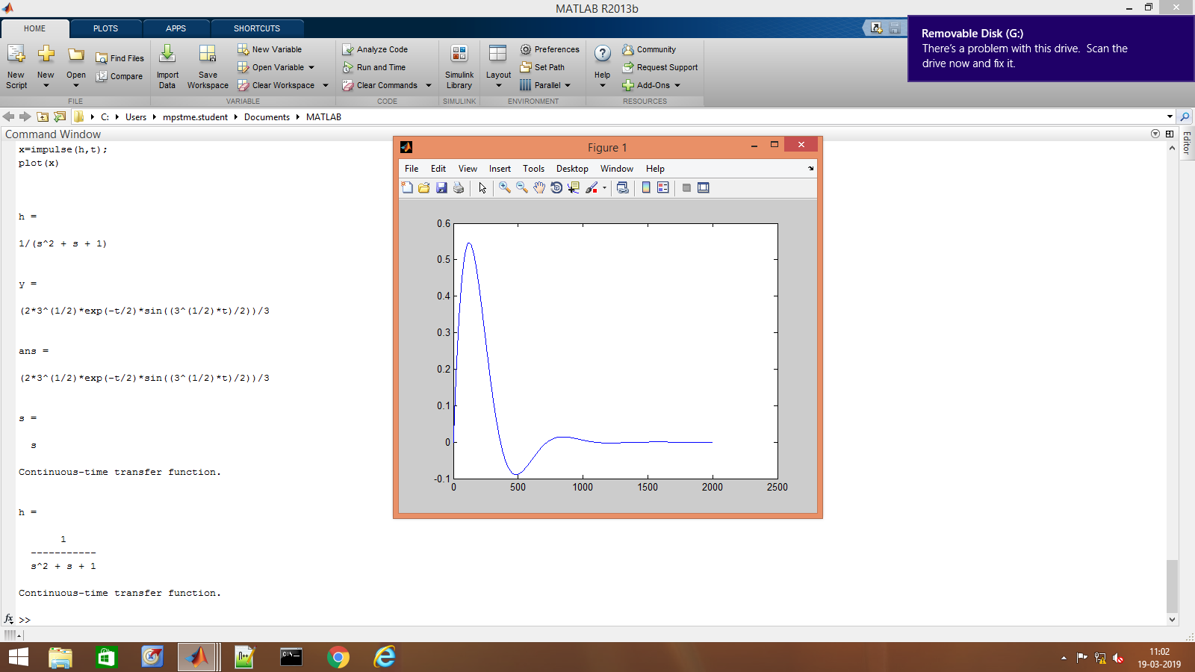

%(Q2)

syms t real;

syms s complex;

h=1/(s^2+s+1)

y=ilaplace(h)

simplify(y)

s=tf('s')

h=1/(s^2+s+1)

t=0:0.01:20;

x=impulse(h,t);

plot(x)